**1.** From the following table, write a SQL query to find those employees who get a higher salary than the employee whose ID is 163. Return first name, last name.

*Sample table*: employees

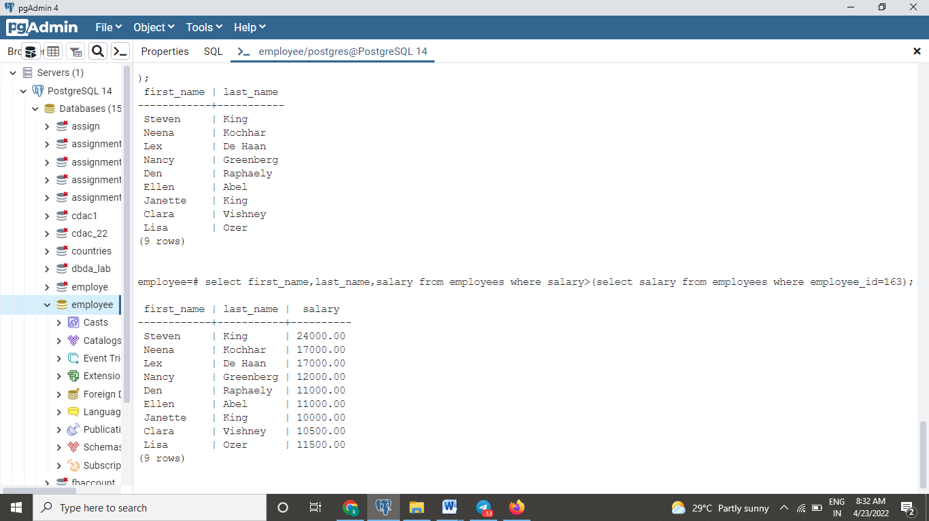

**2.** From the following table, write a SQL query to find those employees whose designation is the same as the employee whose ID is 169. Return first name, last name, department ID and job ID.

*Sample table*: employees

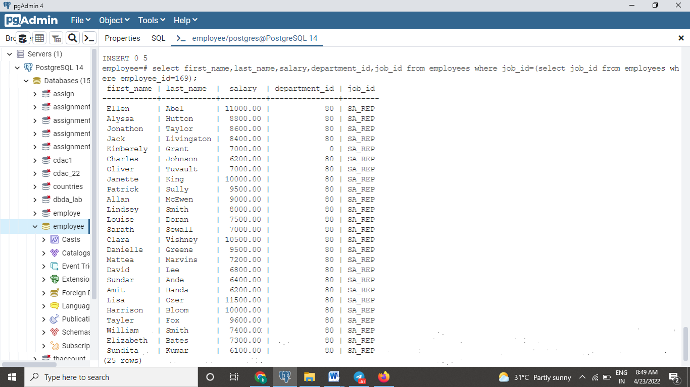

**3.** From the following table, write a SQL query to find those employees whose salary matches the smallest salary of any of the departments. Return first name, last name and department ID.

*Sample table*: employees

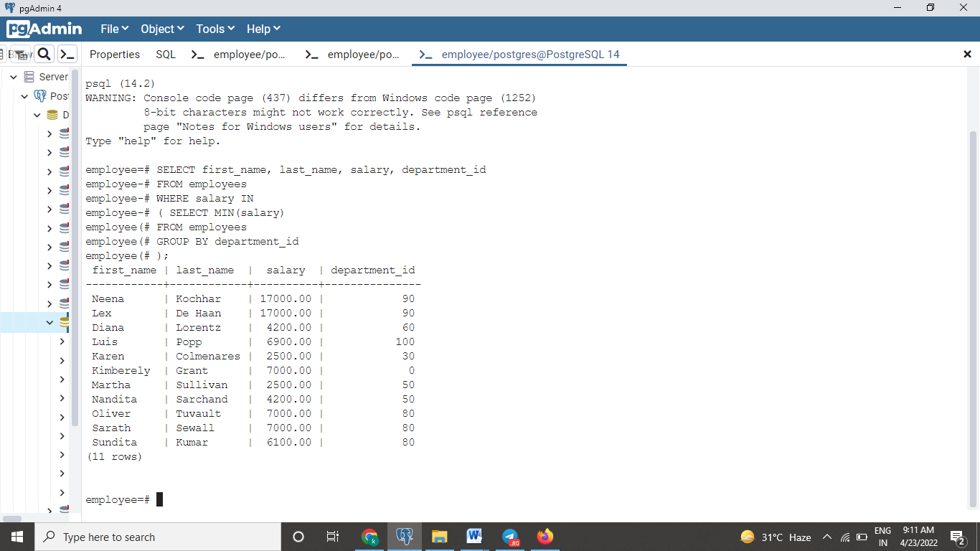

**4.** From the following table, write a SQL query to find those employees who earn more than the average salary. Return employee ID, first name, last name.

*Sample table*: employees

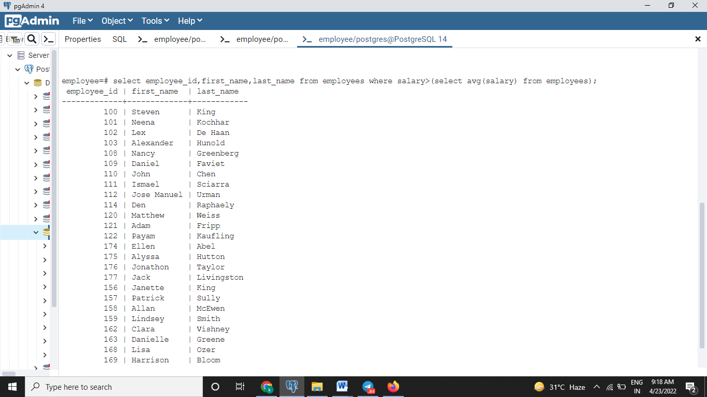

**5.** From the following table, write a SQL query to find those employees who report that manager whose first name is ‘Payam’. Return first name, last name, employee ID and salary.

*Sample table*: employees

**6.** From the following tables, write a SQL query to find all those employees who work in the Finance department. Return department ID, name (first), job ID and department name.

*Sample table*: employees

*Sample table*: departments

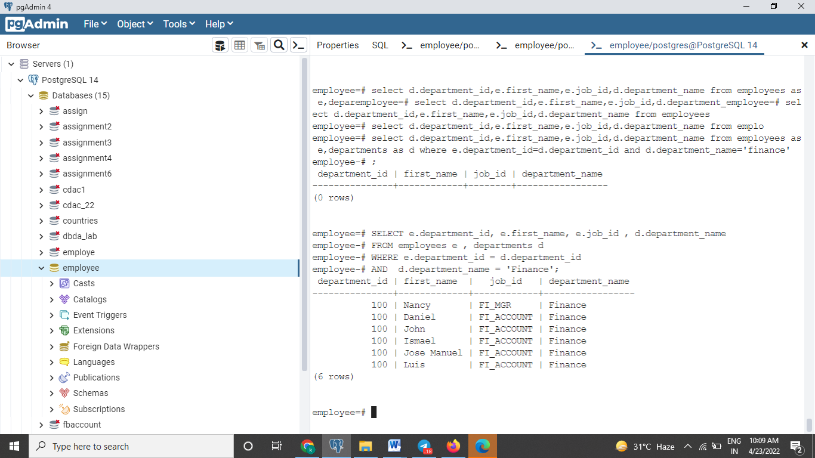

**7.** From the following table, write a SQL query to find the employee whose salary is 3000 and reporting person’s ID is 121. Return all fields.

*Sample table* : employees

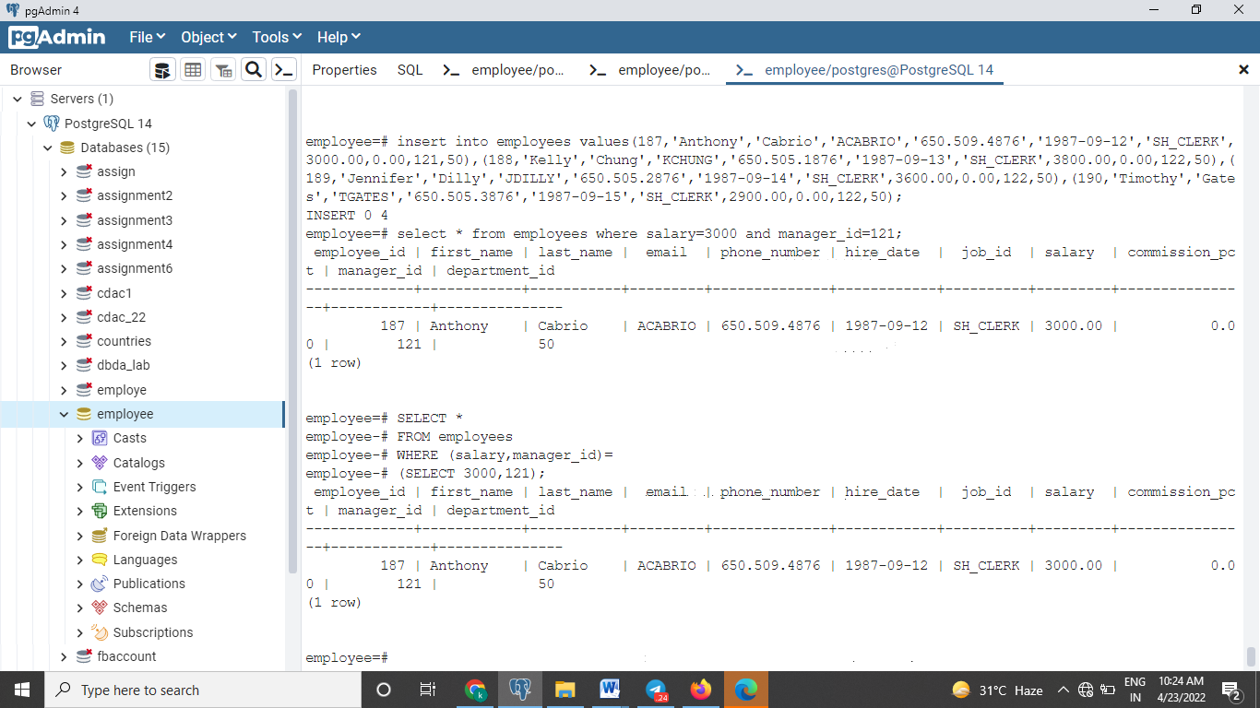

**8.** From the following table, write a SQL query to find those employees whose ID matches any of the number 134, 159 and 183. Return all the fields.

*Sample table*: employees

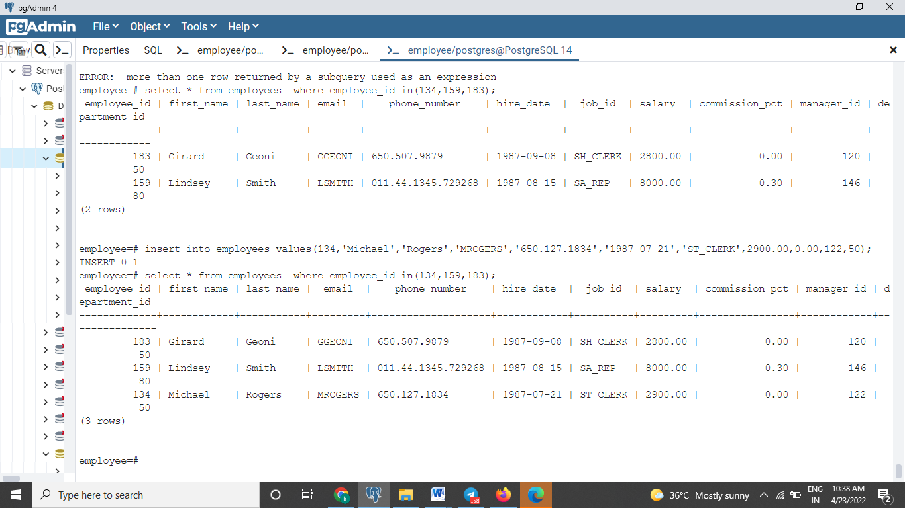

**9.** From the following table, write a SQL query to find those employees whose salary is in the range 1000, and 3000 (Begin and end values have included.). Return all the fields

SELECT * FROM employees WHERE salary BETWEEN 1000 and 3000;